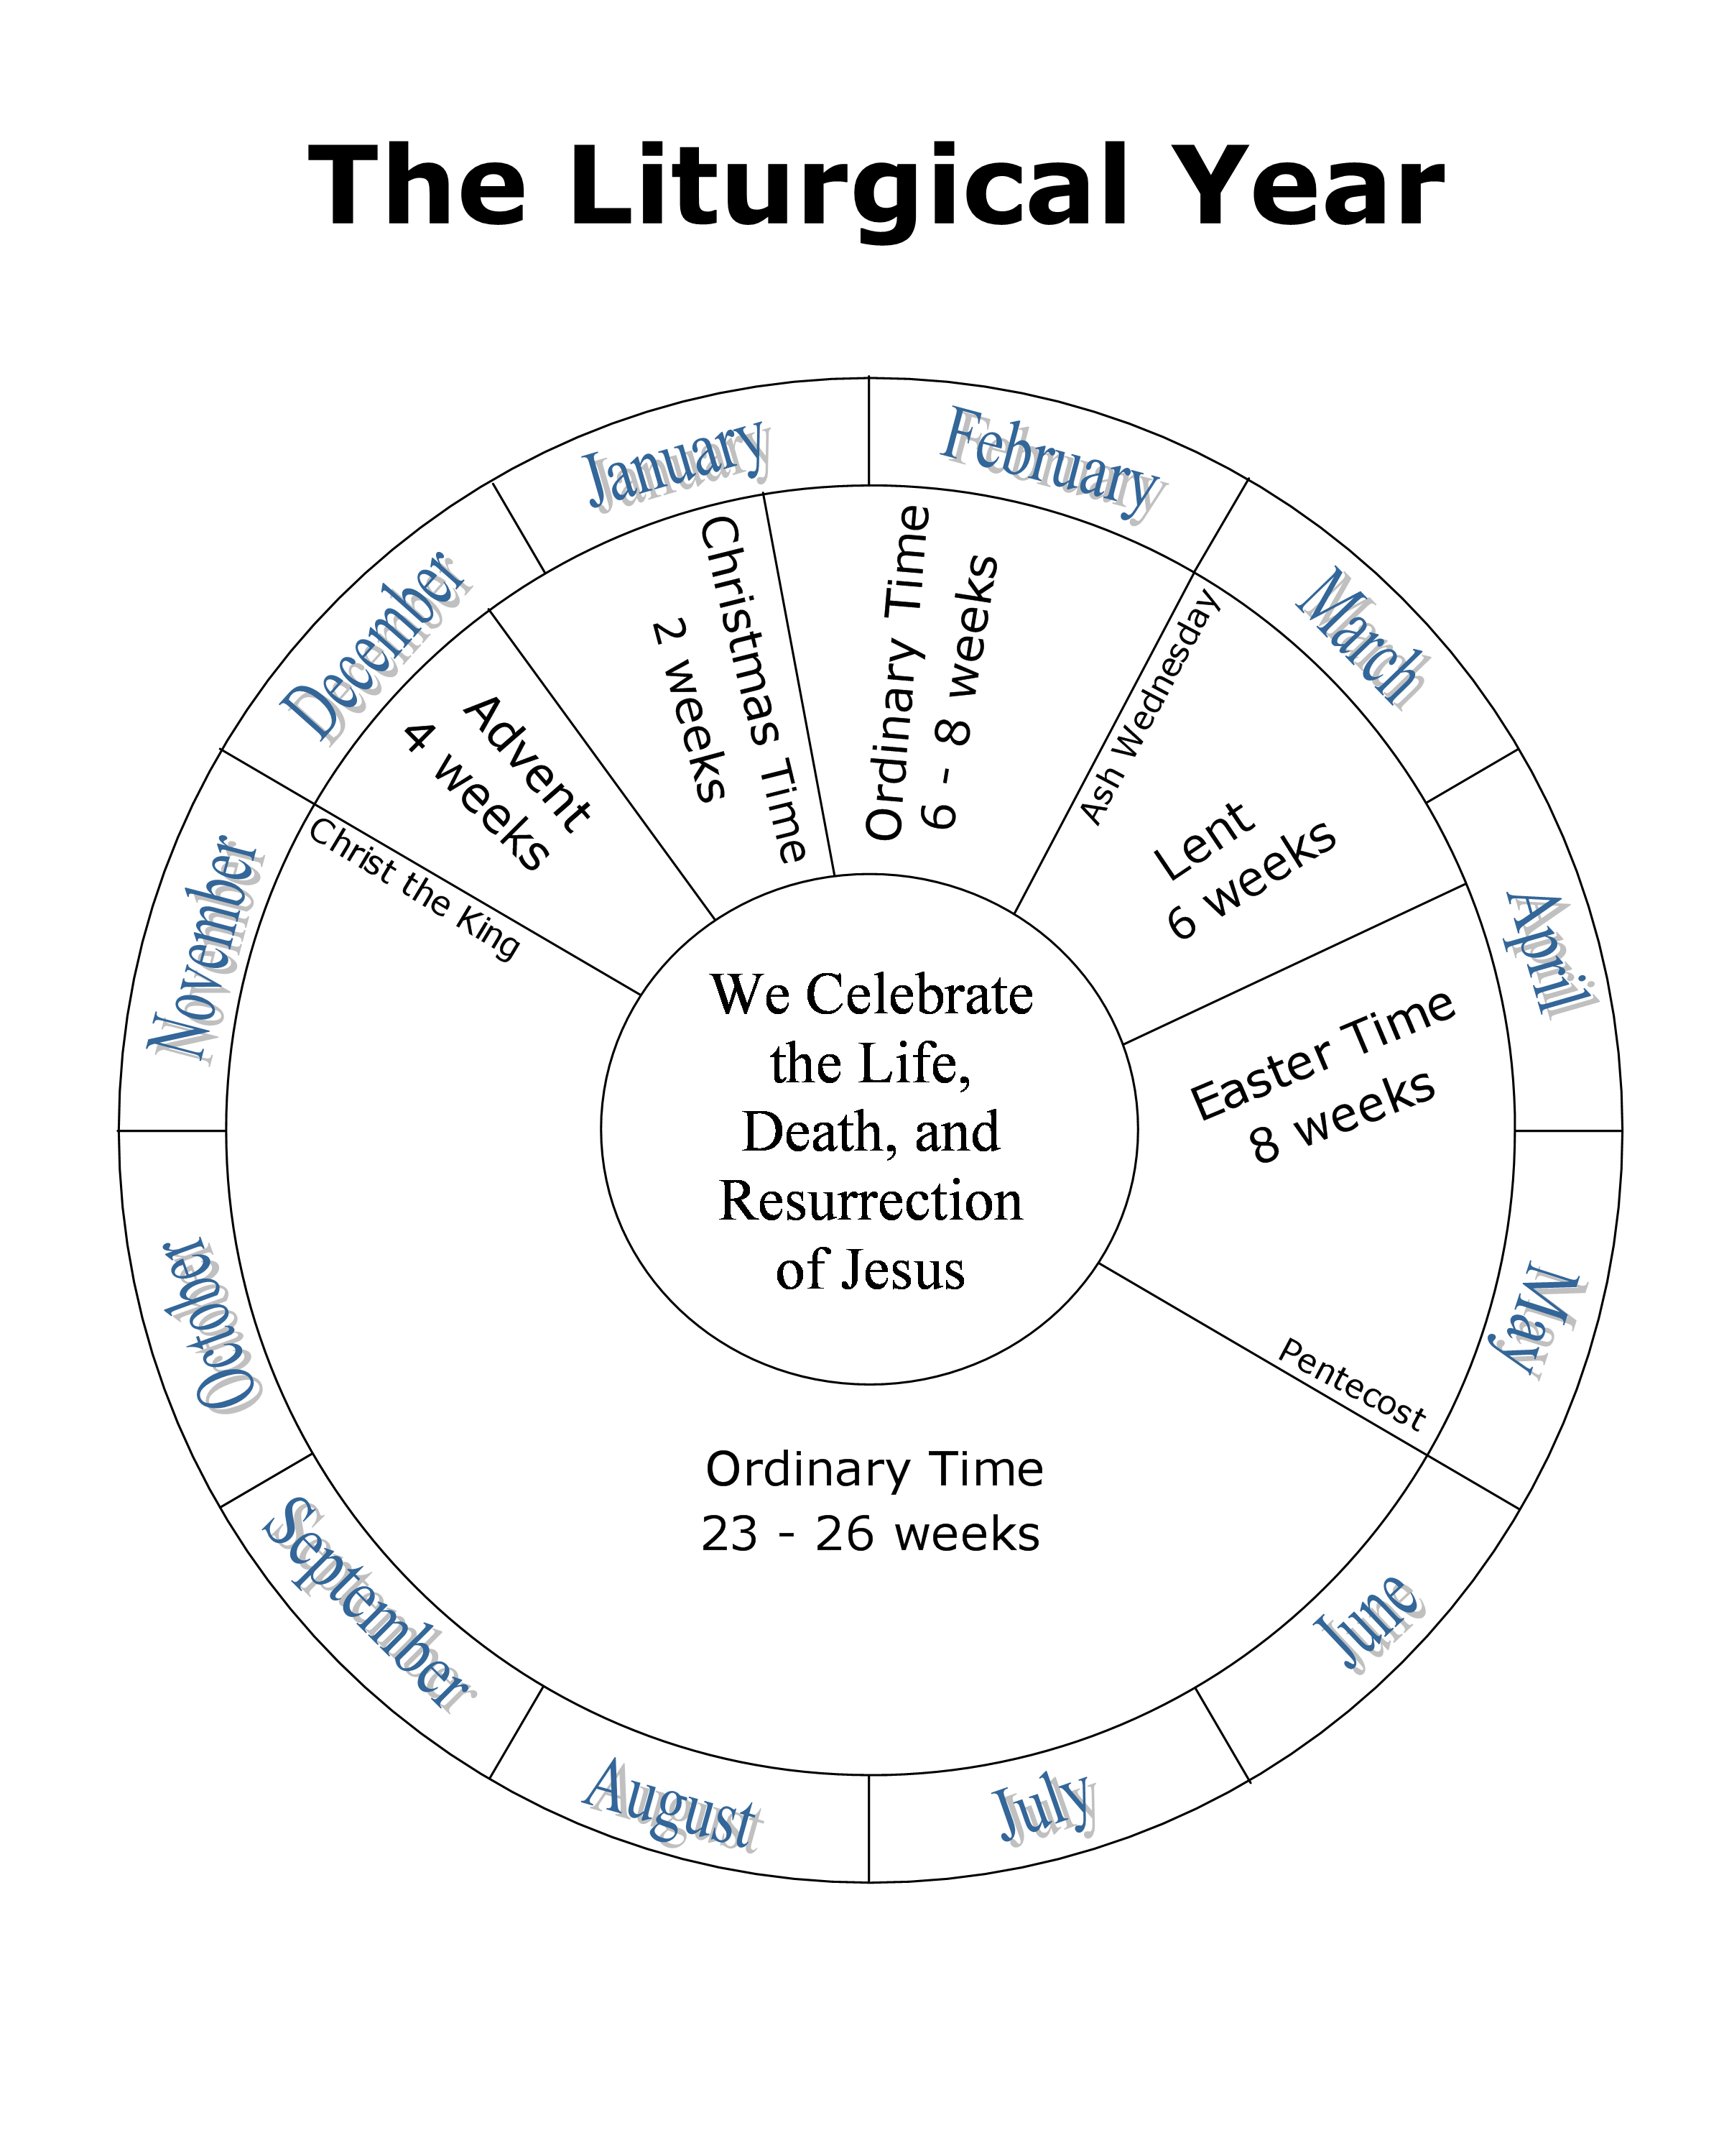

The Liturgical Year

Use the Liturgical Year Calendar to do the following activities.

1. Color Advent and Lent violet.

2. Color Ordinary Time green.

3. Leave Easter Time and Christmas Time white.

4. The longest season of the liturgical year is _______________________.

5. The shortest season of the liturgical year is _______________________.

6. The new Church year begins on the first Sunday of ____________.

7. Lent begins on ______________________.

8. ______________________ begins on Easter Sunday evening and ends on Pentecost Sunday.

9. Ordinary Time is celebrated ______ times during the liturgical year.

10. The year ends on the feast of ______________________.

Answers: (You can use a word bank that is printed on the board for younger students).

4. Ordinary Time

5. Christmas Time

6. Advent

7. Ash Wednesday

8. Easter Time

9. two

10. Christ the King

